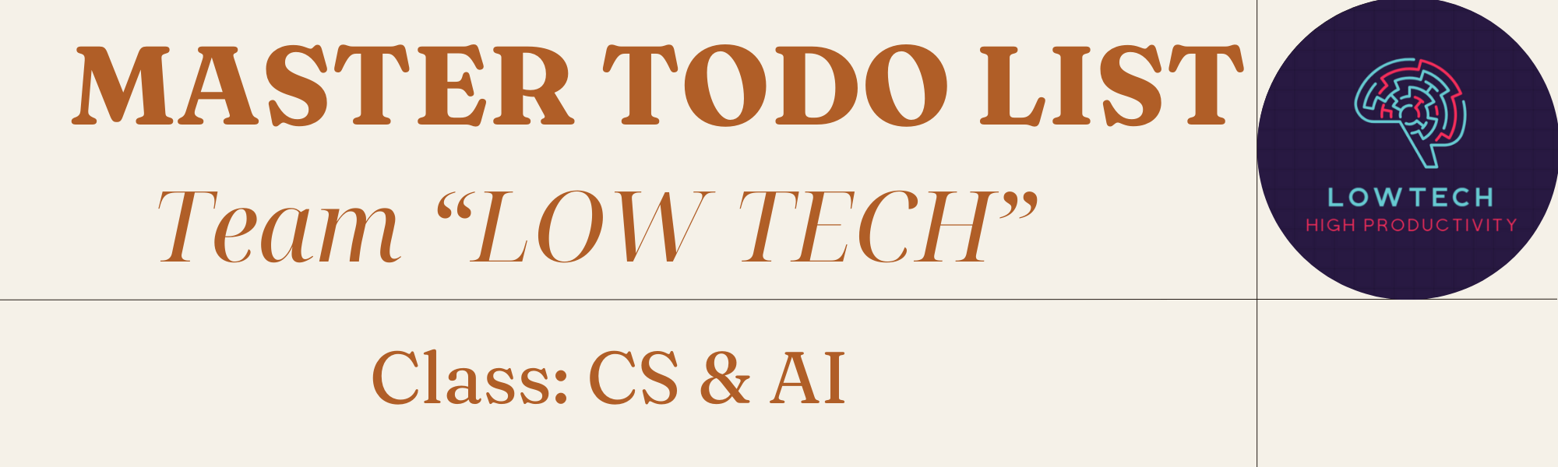

WORK BREAKDOWN
CEO - SWANIE | - Setting strategic direction for the whole team and making some important decisions  - Planning different stages and assigning tasks according to team member’s strengths and expertise  - Making sure the project progress goes smoothly as planned  - Guiding other members and solving problems  - Being a communicator who presents questions to the teacher
CIO - BAOCHI | - Receiving all member’s files and documents, for example, personal logs  - Arranging and submitting assignments on Lexue, such as PPT slides, Word documents, videos, quizzes, games, etc.  - Staying updated on notifications of new stages for the group project on Lexue, especially the due date in order not to be late
CTO - DARA | - Paying attention to the tools and technology used  - Searching for useful tools that could help the team project in some phases, for example, AI creating logos, editing video apps, ...  - Suggesting team members with helpful tools or websites
Writer and Tester - LIAM | - Building the structure of scripts, PPT slides  - Taking notes of regular meetings, project drafts or discussions and sharing in group chat  - Checking the content in other members’ assignments and then giving feedback
Designer - HARVIE | - Finding suitable templates for designing things  - Editing PPT slides with fantastic animations and effects  - Making project assignments engaging and well-organized  - Sharing premium account for group designing
GROUP | - Getting on well with each other, trying not to lose temper when discussing  - Keeping track of the project progress in each stage  - Being willing to learn from others and give our viewpoints and comments on the project  - Preparing tasty food when meeting 🥰

DETAILED TO-DO LIST
PLANNING - MODULE RESEARCHING | Create a WeChat group for contact  Holding the first meeting  Clarify project goals and objectives, define key deliverables  Select a module among the five ones given by the teacher (BIG DATA & CONNECTIONIST AI)  Divide project roles and responsibilities  Set a plan for different phases  Take the very first look at the module generally  Truly understand what the team is going to work on  Research for foundational concepts about the modules following the divided parts
DATA COLLECTION - PREPROCESSING | Identify information resources: textbooks, Youtube videos, ChatGPT, Wikipedia, Google websites...  Divide the module into areas and aspects for easier researching  Try our best to find the information about the modules that meet these demands: accurate, covering wide enough aspects  Submit the documents to the tracking sheet before due date  Hold regular meetings to share information and the next steps  Share with others what researched and prepared  Give feedback to each other, work on the data one more time according to other members’ comments  Brainstorm the structures of the next assignments, put all information found in a logical and organized way  Make a Word script document for PPT slides and videos
MODEL DESIGN - IMPLEMENTATION | Design PPT slides and video tutorials, making sure that they are all engaging and well-structured  Divide tasks in more detail for each member  Support others with particular work stuff like designing, recording, editing, voiceover...  Hold meetings every week, about 2-3 times  Keep track of the project progress carefully on Google Sheet, complete things with personal status  Hand-in the assignments on Lexue before the deadline
FINAL PRODUCTION - TESTING | - PDF Slides (submitted in the previous phase)  - Study Guide  First structure the study guide (similar to writing a book for beginner)  Study guide should be separated into different chapters in a logical way, covering a big picture with a wide range of aspects (but not that really deep)  Design it to be engaging, interesting, good-looking  The length should be 100 pages on average if we can manage well  - Lexue materials  Brainstorm the structures of files uploaded on website  Create module-related materials like quiz, game, videos tutorial  What should we do to approach these things as well as possible?  Browse through all the materials on Lexue by previous students  Understand the keypoints and note down important things  Be creative and enthusiastic at all time  Try to explore new things, for example, make attempt to coding a game  Hold regular meetings for better understanding other members and tracking the progress

